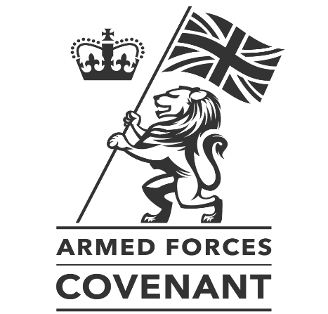

ARMED FORCES COVENANT COMMUNITY CONFERENCE 2022
King’s House Conference Centre, Sidney Street, Manchester M1 7HB, 18 May

Registration From 09.30
Doors open from 09.30. Registration takes place in the foyer of the Conference Centre. Please report to the registration table on arrival to collect your delegate pack and register for workshops. Tea & coffee is served upstairs.

Welcome (Auditorium, Second Floor) 10.00-10.10
The Conference programme begins at 10.00, with a welcome from Jenna Clare and Bryony Hamilton, joint Heads of the Armed Forces Covenant Team at the Ministry of Defence.

Introductory address (Auditorium, Second Floor) 10.10-10.25
Discussing the importance of the Covenant, its future, and the vital role that local authorities and other bodies play in delivering the Covenant locally.

GMCA and the Covenant (Auditorium, Second Floor) 10.25-10.40
Steven Pleasant, Chief Executive of Tameside Council, talks about the work of Greater Manchester Combined Authority to deliver the Covenant and to support the local Armed Forces Community.

Implementing the new Covenant Duty (Auditorium, Second Floor) 10.40-11.10
The Covenant Legislation Team at the Ministry of Defence discusses the new Covenant Duty – its purpose, aims, timeline for implementation and how in-scope bodies are being supported to prepare for it.

Break and refreshments (Auditorium; Cafeteria) 11.10-11.30
Tea & coffee is served in the Auditorium and the First Floor Cafeteria.

Workshops I (Various locations) 11.30-12.30
On arrival, delegates will be invited to register to attend one of six workshops in the morning:
Workshop 1: Understanding the Covenant Duty (Auditorium, Second Floor)
The MOD Covenant Legislation team leads a workshop on the requirements of the new Duty and what is in-scope.
Workshop 2: Meeting the Covenant Duty (First Floor Hall)
A local authority-led discussion on ideas for how to meet the Covenant Duty once it enters into force.
Workshop 3: Our Community, Our Covenant 3 (Seminar Room 5)
The team at Shared Intelligence leads a workshop discussing the initial findings from the Our Community, Our Covenant 3 research project on local delivery and impact of the Covenant over the last ten years.
Workshop 4: The Armed Forces Covenant Fund Trust (Seminar Room 3/4)
The Covenant Fund Trust leads a workshop exploring learning from the Strengthening Delivery of the Covenant funding programme, and discussing the resources available from the Trust to help local authorities and other bodies deliver the Covenant, including the new Knowledge Network.
Workshop 5: The Office for Veterans’ Affairs (Seminar Room 2)
The team at the OVA leads a workshop introducing the work of the OVA and the Veterans Strategy.
Workshop 6: Veterans UK Services (Seminar Room 1)
MOD’s Veterans UK team leads a workshop giving insight into the services they offer, including the Veterans Welfare Service, Defence Transition Services and Integrated Personal Commissioning for Veterans.

Lunch, networking and stands (Various locations) 12.30-13.30
Lunch is available in the Auditorium, the First Floor Hall or the First Floor Cafeteria. Please also find time to visit the exhibition stands at the back of the Auditorium.

Welcome back (Auditorium, Second Floor) 13.30-13.35
Jenna Clare and Bryony Hamilton welcome delegates back for the afternoon portion of the Conference.

Our Armed Forces family story I (Auditorium, Second Floor) 13.35-14.00
Wg Cdr Philip Holdcroft talks about his family’s story in the Armed Forces, caring for a child with leukaemia, and the ways in which the Covenant and public services have helped his family over the years.

E-learning on the Armed Forces Covenant (Auditorium, Second Floor) 14.00-14.10
Phil Deakin, Covenant Project Worker at Warwickshire County Council, outlines the work on the refresh of the Covenant e-learning programme, including a brand-new induction module.

No Homeless Veterans campaign (Auditorium, Second Floor) 14.10-14.25
Richard Gammage, Beverley Russell and Nick Coverdale from Stoll – the veterans’ housing charity – discuss the recent launch of the No Homeless Veterans campaign.

Break and refreshments (Auditorium; Cafeteria) 14.25-14.45
Tea & coffee is served in the Auditorium and the First Floor Cafeteria.

Workshops II (Various locations) 14.45-15.45
On arrival in the morning, delegates will be invited to register to attend one of six workshops in the afternoon. The workshops are the same as those run in the morning. See above for details.

Veterans Covenant Healthcare Alliance (Auditorium, Second Floor) 15.45-16.00
Lt Col (Retd.) Guy Benson, leader of the Veterans Covenant Healthcare Team at NHS England, talks about the ‘Veteran Aware’ accreditation scheme for NHS providers.

Our Armed Forces family story II (Auditorium, Second Floor) 16.00-16.25
Lt Col Brian Gordon RAMC, Commanding Officer of 225 (Scottish) Medical Regiment, talks about his family’s story in the Armed Forces, caring for a child with additional needs, and the ways in which the Covenant and public services have helped his family over the years.

Conclusion and goodbye (Auditorium, Second Floor) 16.25-16.30
Jenna Clare and Bryony Hamilton conclude the Conference.

